1. Class 2nd Jan 10,2020

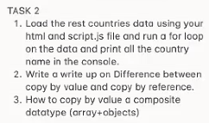

Pass by reference and pass by reference

Lets take first example -

A = 10

B = "20"

So this is you know pass by value

C = A

This is also a pass by value here value of the a goes to the C

So if do C += 1 then C == 11

But here A == 10 still [so this is pass by value not the reference]

Now

D = [1,2,3]

Now,

E = D

So here you will notice or js does that

It assign the reference to the E not the entire array

So id E.push(4)

Then still

E == [1,2,3,4]

D == [1,2,3,4]

As we are giving the reference to the memory address not the value

Exactly same thing happen when pass the value in the function that is actually value is getting passed by reference.

1. Copy by value the the composite object So here we have three methods to do the same
2. Using […a] this will copy the value b = […a]
3. Using obeject.assgin -> var a = Object.assign([], b)
4. Using JSON.stringify and JSON.parse()

Var b = JSON.parse(JSON.stringify(a))

Using these three method we can assign the composite vars by the value not only by reference